Tyler Lonestar Softball Chapter
Training Outline
April 11th, 2021

- Rule and common practice of handling players wearing jewelry.
- When is a Ball Game declared over?
- Review of 2 Person Mechanics
- Review of 3 Person Mechanics

1

Rule 3-2, Article 12
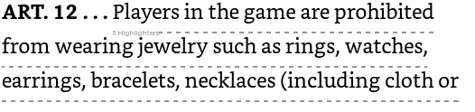
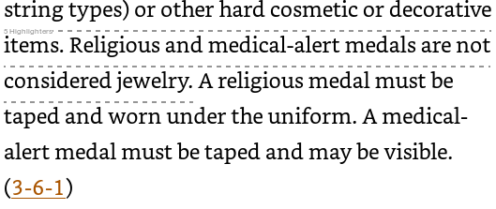

Per the rule above YOU are not allowed to let a player participate if she is wearing any JEWELRY. Let that sink in a minute.. NO JEWELRY!! The are not allowed to cover earrings with tape or a band aide.. They cannot do this.. If you notice a player has jewelry on what action should you take?
Let’s think back the HEAD COACH has already certified that their players are properly equipped by rule correct?
So here is how I handle it I tell the player and the coach that the jewelry must be removed and that this is the Coach’s warning for the game. I also remind the coach that if this happens again that themselves and the player found in violation will be in the dugout for the remainder of the game. If the removal could potentially hold up the game or if the player says that they cannot remove the jewelry, then I ask the coach for a replacement player until the violator becomes eligible to play again. This will count as a substitution.
Please bare in mind that according to the rule above Medical and Religious Medals ARE NOT considered jewelry however if a Religious Medals is worn it must be taped and kept under the uniform. If a Medical Medal is worn, then it must be taped and may be visible. In either instance it is still up to the umpire to allow the wearing of the medal and how it is worn. Safety is always first when it comes to dealing with anything that happens or you allow during a game.

Check out the Case Book Scenarios:
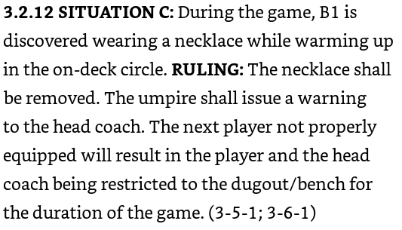
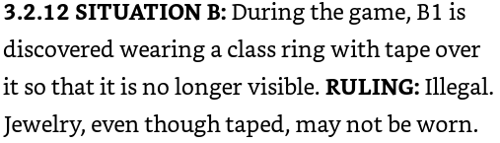
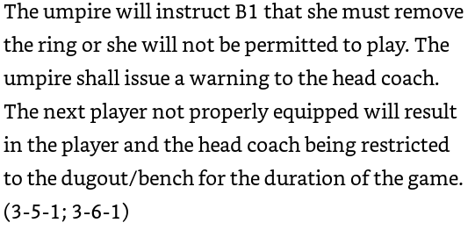

2
Q: When Does a game end?
The game ends when either team has secured enough runs as to be declared the winner however ensure that all facets are checked prior to the declaration of the game being over.
- Run Rule
- All Play has stopped
- Verification of score

Q: Are we announcing, “Ball Game” too early?
Remember that even if a team has secured enough runs to end a contest that if there is play going on ALL PLAY must be allowed to cease prior to you doing anything.
Before I call a ball game I double check with the scorer and then I will make the announcement of “Ball Game”. At this moment I have declared this ball game over, so I meet my partner and we leave the confines of the field together.

If you are calling ball game while live play is going on, please stop doing this it will get you into trouble.

3
2 Person Umpire Mechanics
The pre-game meeting between you and your partner will be the most important meeting of the game. In this meeting you will discuss the way you want you and your partner to adjudicate the following:
- COMMUNICATIONS throughout the game
- Flyballs to the outfield
- Balls hit down the lines
- Coverage for bases
- Handling of coaches and how they are if you know them
- Anything else you want to discuss
Plate you bear the majority of the responsibility of how the game is officiated however you do not have the authority to overrule your partner.
Base you have the 1st the play on the infield and subsequent plays as needed.
Positions for the Base Umpire
- On first base 18 to 21 Feet and walking the line.
- Watching for the illegal pitch (Feet)
- Watching for the swing/ no swing
- Watching the runner for leaving early
- Watching for a hit batsman
- Between 1st and 2B adjusted as needed by the play of the 2B
- Between 2B and 3B
- If a runner is on 2B shade to the left of the SS
- If a runner is on 3B shade to the Right of the SS
Note: At no time should you be closer to 3B so that you are less than 20 Feet from the line. Stay in the middle of 2B and 3B it makes it easier to adjudicate the play at 1B.
If there is a flyball to the out field the BU comes in and buttons hook and picks up the ball.
PU will be ready to make the call and back up the BU as needed.

4
3 Person Umpire Mechanics
The pre-game meeting between you and your partner(s) will be the most important meeting of the game. In this meeting you will discuss the way you want you and your partner to adjudicate the following:
Note: The 3 Person Umpiring System is designed to ensure that you always have an UMPIRE in front of a runner.
- COMMUNICATIONS throughout the game
- Flyballs to the outfield coverage
- Balls hit down the lines
- Coverage for bases
- Handling of coaches and how they are if you know them
- Anything else you want to discuss
Plate you bear the majority of the responsibility of how the game is officiated however you do not have the authority to overrule your partner(s).
Positions for the Base Umpire(s)
1B and 3B Starting Position
18 to 21 Feet and walking the line
- Watching for the illegal pitch (Feet)
- Watching for the swing/ no swing
- Watching the runner for leaving early
- Watching for a hit batsman
Runner on 1B
1BU Goes to set position
3BU moves to modified B position to adjudicate a steal
Runner on 1st and 2B or 2B only
1BU moves to modified B position in a set position
3BU moves back to 3rd base line and in a set position
Runner on 3rd only
1BU on the 1st Base line in a set position
3BU on the 3rd Base line in a set position

Flyball Coverage-
If 1BU or 3BU are in the counter rotated B or the B Position, then they will chase ALL flyballs in V between the Left and Right fielder. This will include any potential hits that may lead to a potential trap.
IF both 1BU and 3BU are on their foul lines then they split the field.
- If the ball is hit to the Right side of the CF the 1BU will chase
- If the ball is hit to the Left side of the CF then the 3BU will chase
NOTE: In all instances if you chase make the call and then turn back around and observe the follow-on play do come back into the infield until the play is over.

