General Session
SOFTBALL TRAINING
3-14-21

Subjects:
Courtesy Runner
Substitution
Dead Ball Areas/ Media Areas
Tarp within the confines of the Field
Unauthorized Personnel outside of the dugout
Coach return to Coaching Box after being restricted to the dugout

Courtesy Runner (CR)
An eligible substitute that is listed on the lineup card may run for either the Pitching Position or the Catching Position. At NO time during the contest may the same player run for both the Pitching and the Catching positions. This does not matter whether it is the same inning or in different innings. Once a substitute has entered the game in the lineup they can no longer be a CR.

The coach must let the umpire know that they want player # to be the CR for the Pitcher/Catcher. When you go to inform the opposing Head Coach that player # is now the CR for the Pitching/Catching Position not a specific player #. Circle the Player # on the lineup card listed in your substitutes and annotate either P or C for tracking purposes. This will help keep you out of trouble if the coach attempts to have the same player run for the other position in the contest.

Keep these tidbits in mind…

A Courtesy Runner can NEVER replace a Courtesy Runner

If during the event of a play the CR becomes injured or disqualified and cannot continue, the coach may place the Pitcher/Catcher back on base or choose to substitute a player for the CR which by rule means she has substituted for either the Pitcher/Catcher.

If the Pitcher/Catcher identified on the lineup card is CR for in the top half of an inning and they (P or C) become injured or disqualified and cannot face a batter in the bottom half of the 1st inning the CR, then becomes a substitute for that position. The HC may substitute another legal substitute for this substitute.

If during a contest an injury or disqualification occurs, and NO substitutes are available, the CR must be used as a substitute and takes the place of the injured player.

Substitution
There are three (3) categories of Substitution
- Legal
- Unreported
- Illegal

General knowledge- All players have 2 entries onto the lineup card (First 9/10 Spots on the lineup card). Being used as a CR does not constitute a Substitution. When a player is listed in one of the top 9/10 slots on the lineup card at the beginning of the contest this is their 1st entry and they have one re-entry left.
Legal Substitution- Has one or two entries remaining on the lineup card and if already used on the lineup card goes back into the same position in the batting order or Flex position.
Unreported Substitution- Has remaining entry(s) however has entered the contest without reporting to the umpire or was not listed on the lineup card at the Coaches Meeting. As the umpire all you do at the time this is brought to your attention is one confirm that they are a legal substitute, if they are place them in the game for the player they substituted for. If not on the lineup card add them and place them in the game for the player, they are substituting for. Inform the Opposing HC and inform the Offending HC that they are receiving a warning and any other instances of this nature will result in the player and themselves being restricted to the dugout for the remainder of the contest. Have them double check the lineup card with you.
Illegal Substitute- Basically one of two things has transpired for a player to become an Illegal Substitute.
- Player has used both of their entries
- Player has been disqualified from the contest by an umpire.
If an illegal substitute is discovered in the game on Offense and on base and its brought to the umpire’s attention the umpire will pause the game, pull out their lineup card holder confirm the accusations and declare the illegal player on base out and restrict them to the dugout for the remainder of the contest. If the illegal player is at bat, the illegal player will be called out. The player who was supposed to be at bat loses their turn and the illegal player is restricted to the dugout for the remainder of the contest.
If the illegal substitute is discovered on Defense and brought to the umpire’s attention depending upon the timing of the notice the following could take place.
- If alerted prior to next pitch legal or illegal and a play has been made by the illegal substitute the offended HC has options, they may keep results of play or they may elect to nullify the play (out is nullified and runners are returned to base occupied at the time of pitch). The batter is allowed to bat again with the same count. The illegal substitute is restricted to the dugout for the remainder of the contest.
- If alerted after another pitch legal or illegal the play stands but the substitute is restricted to the dugout for the remainder of the contest.

Note.
If in the determination of the umpire that this action was done maliciously then the HC and the player are ejected from the contest for an Unsporting Act.

Dead Ball/Media Areas
Dead Ball Areas are established by the home team coach/site. These can be either an area where a tarp is stored, or an area marked for media personnel.
Couple things to remember about DB areas
- If a player has a foot completely in the DB area and makes a catch. The umpire sounds Dead Ball the catch is nullified and play resumes after the umpire puts the ball back into play where it was before the DB.
- If a player makes a catch and then carries the ball into the DB area the umpire will announce DB and give the signal for the out. If there are runners on base and this out did not result in the 3rd out all runners will be advanced 1 base.
- Media areas are allowed by rule however we (UMPIRE’S) control the playing field once we take the field until we leave. If a person(s) become a deterrent to us officiating the game and they choose not to listen to reason have the Administrator on Duty (AD) remove them and get on with your game.
- At no time during live play should Media Personnel be on the field or its confines unless they are in a DESIGNATED MEDIA AREA.

Rules for TARPS that are within the confines of the field and not in designated Dead Ball areas.
- May lean on
- May not elevate from (Ball declared dead)
- If you go fishing were playing until you hold up your hands

Unauthorized Personnel Outside of the Dugout
Always Remember:
Coaches, Team Members, Team Equipment ALL belong
in their dugout.
Exceptions:
- One of 9 Defensive Players
- The Batter in the Batter’s Box
- The On-Deck Batter
- Coach(s) in their respective Coaching Box

Below are situations from the Case Book where being outside the dugout can cost you dearly.
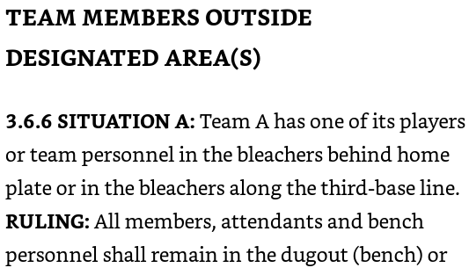
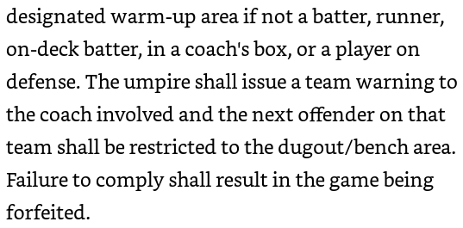
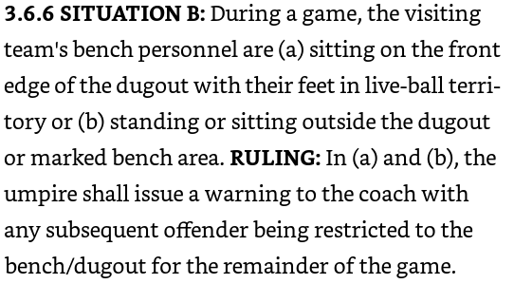
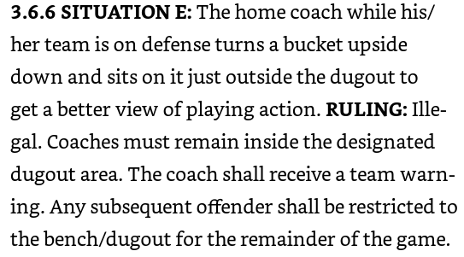
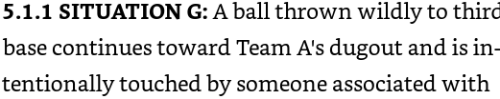
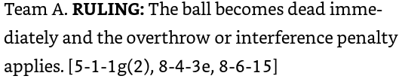

Overthrow Rules/Being hit outside of the dugout
Offensive (Interference) 8-6-15
If the ball becomes blocked due to offensive equipment not involved in the game, the ball is ruled dead and runners are returned to the base touched at the time of the blocked ball. If the blocked ball prevented the defense from making an out, the runner being played on is called out. If no play is obvious, no player is out, but runners are returned to the last base touched when the ball was declared dead.
Defensive- 8-4-3e
All runners will be awarded to bases, and the award will be governed by the positions of the runners when the ball left the fielders hand. Runners may return to touch a missed base or base left too soon. If two runners are between the same base, the award is based on the position of the lead runner.
What is a Blocked Ball-
A blocked ball is a live ball, pitched, batted, or thrown, which is touched, stopped or handled by a person not engaged in the game; or touches an object which is not part of the official equipment or official playing area; or touches loose equipment.
Biggest Culprits= Coaches and Buckets if this happens after warning them from the beginning. Make it HURT

